**Muscle-BioAmp-Candy**

A candy size ElectroMyography (EMG) sensor for precise muscle bio-potential signals recording at an affordable cost. It comes with a fixed gain of x2420 and BandPass filter of 72Hz - 720Hz. To record the EMG signals you can use any standalone ADC like ADS1115 or any microcontroller development board with an ADC of your choice like Arduino UNO/Nano.

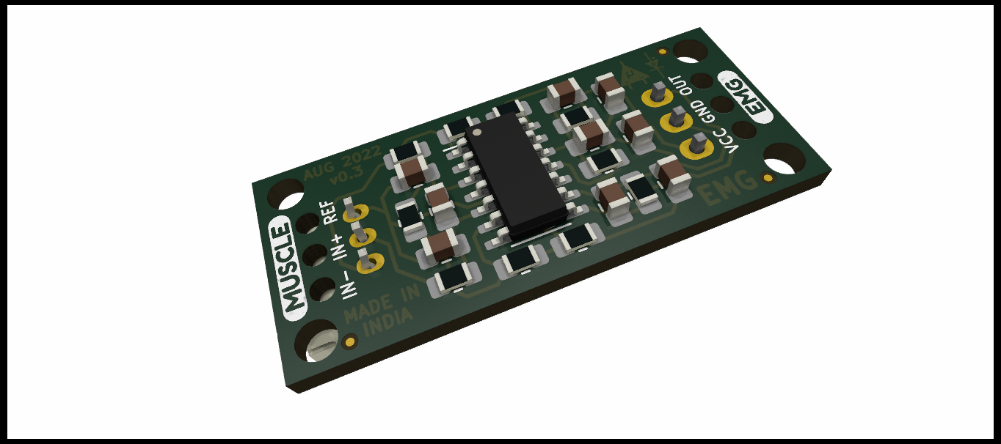

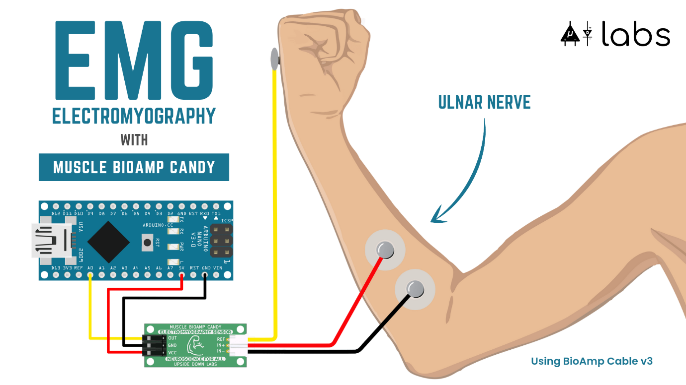

**Hardware**

Muscle BioAmp Candy has been created using KiCad and all the design files can be found under hardware folder. Images below shows a quick overview of the hardware design.

**PCB Front-**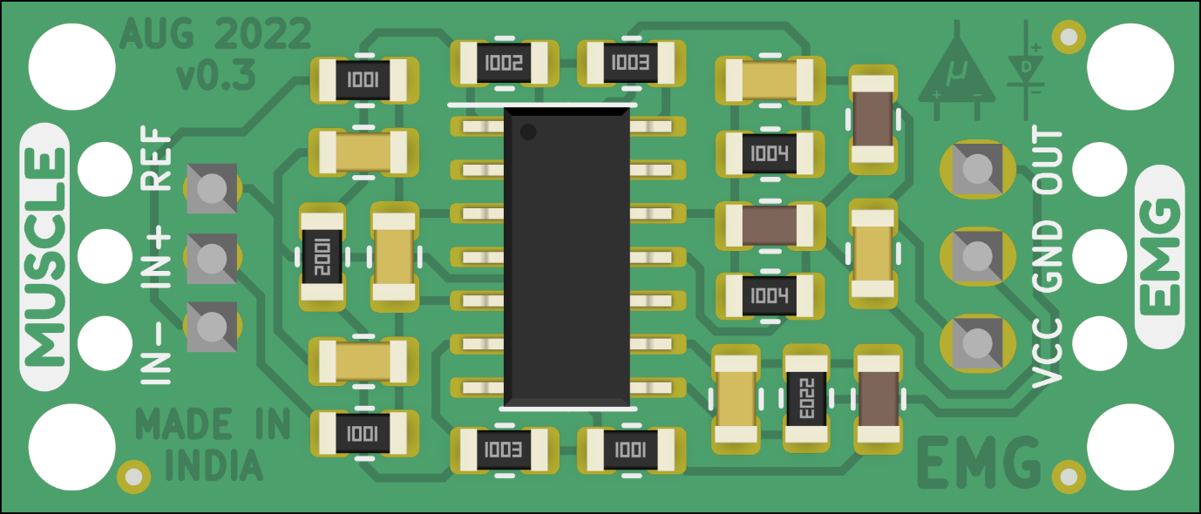

**PCB Back**

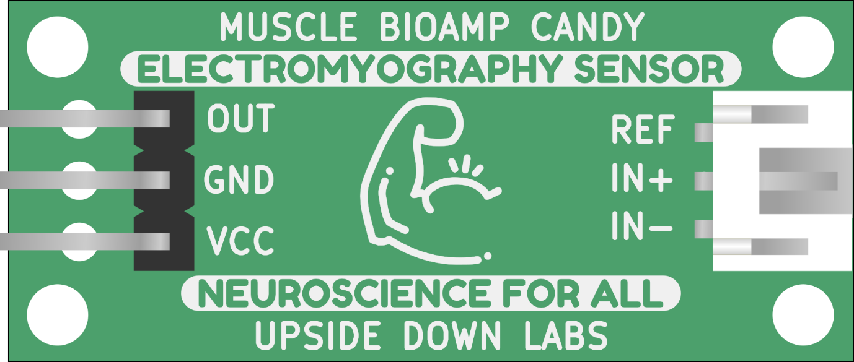

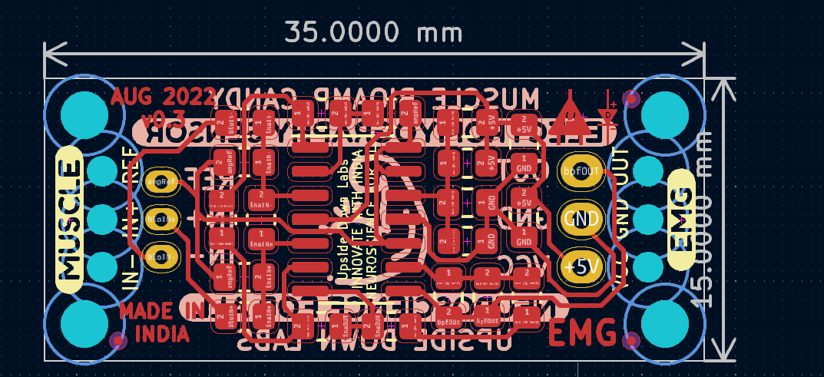

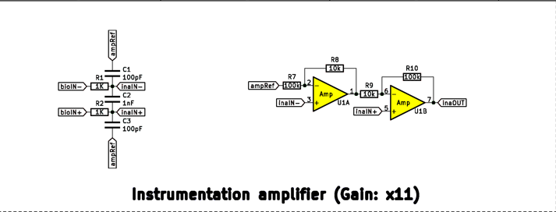



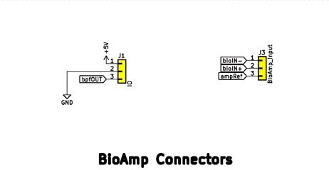

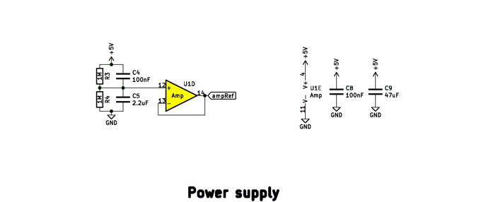

**Reference-**

Muscle-BioAmp_Candy

<https://github.com/upsidedownlabs/Muscle-BioAmp-Candy>